**GitHub tutorial**

1. After creating your GitHub account, go to: <https://windows.github.com/>, if your OS is Windows (only available for vista, 7 and 8); or to: <https://mac.github.com/>, if you use a Mac (only for OS X 10.8 or later) and start your download.

WINDOWS



MAC



***Since this step, I´ll only be able to guide you through the Windows installation progress.***

1. Install GitHub on your computer (it may take several minutes).
2. Write your user name and password (the same you registered on the web), and click “Log in”.

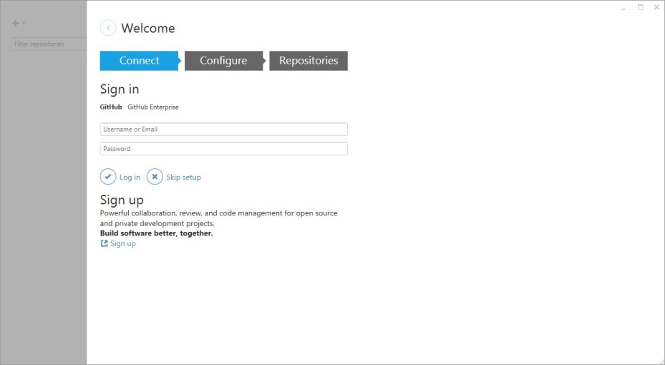

1. Click on “Continue.”

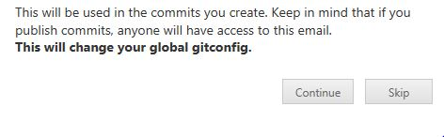

1. Select “Skip” (we´ll do this later).

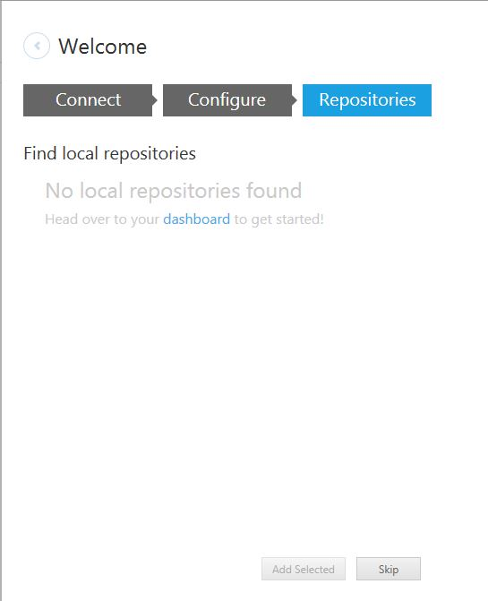

1. Click on the highlighted sign on the upper-right side of the window.

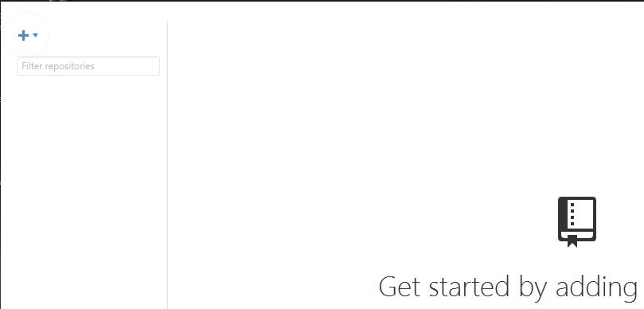

1. Select the “Clone” option.



1. Click on every repository you want to have on your computer and then choose the “clone________” option on the bottom of the window (repeat step 7. and 8. for each repository you want clone).

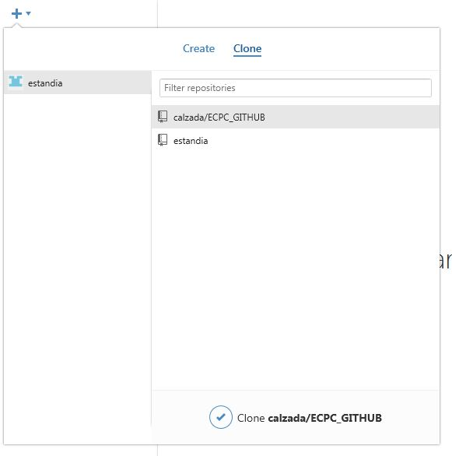

1. Now you have all your repositories on your computer.

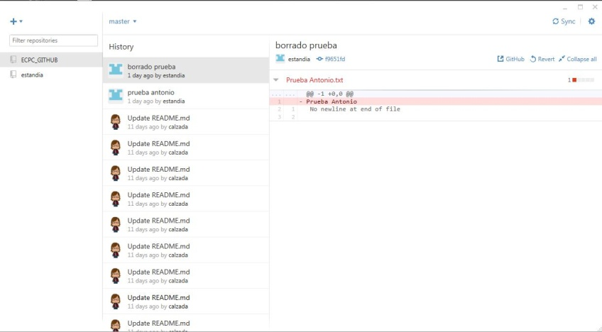

1. Before you start working, you must synchronize the repositories to make sure you´re working with the files last version. To do that, click on the “Sync” button on the upper-left side of the window.



1. After synchronizing, choose the folder where the files you´re going to work with are. You can find the folders by clicking on “master”, on the middle-upper side of the window.

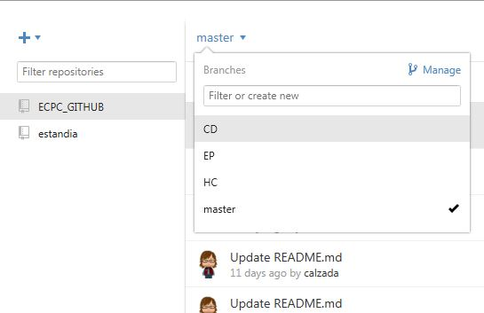

1. Once you have selected the folder, you can search for the file you want to work with. To work with the file on your computer, right-click on the repository, choose the “Open in Explorer” option and drag the file to your desktop.

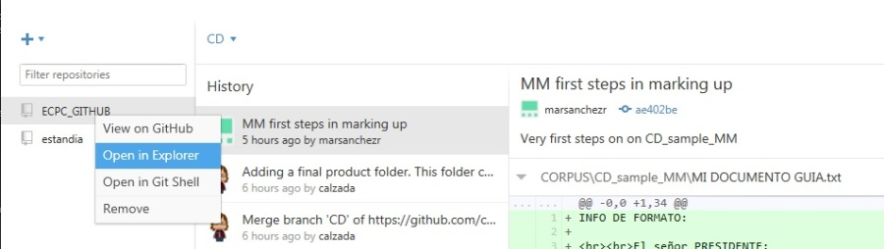

1. After your work is done, you can upload it to the cloud by choosing once again the “Open in Explorer” option and dragging the file back to the folder you took it from (or to any other folder on the repository).

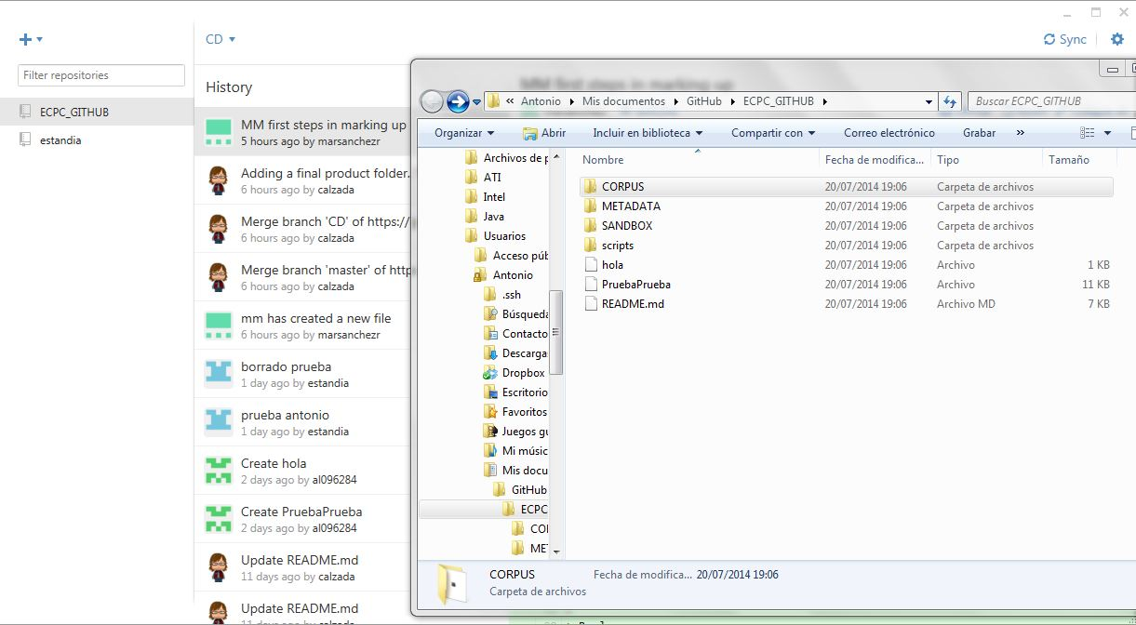

1. To register your work, you must synchronize once again.



1. Now every change you made is available for everyone.